Project Design Phase-II
Data Flow Diagram & User Stories
Date | 28-10-2026
Team ID | SWUID2026402568
Project Name | HotelPro - Complete hotel booking and management solution
Maximum Marks | 4 Marks

Data Flow Diagrams:
A Data Flow Diagram (DFD) illustrates how data moves within the HotelPro management platform. It captures how users (guests, receptionists, housekeepers, and managers) interact with the system, how information flows between different processing modules, and where data is persisted in database stores.
DFD LEVEL 0 — HOTELPRO MANAGEMENT SYSTEM:
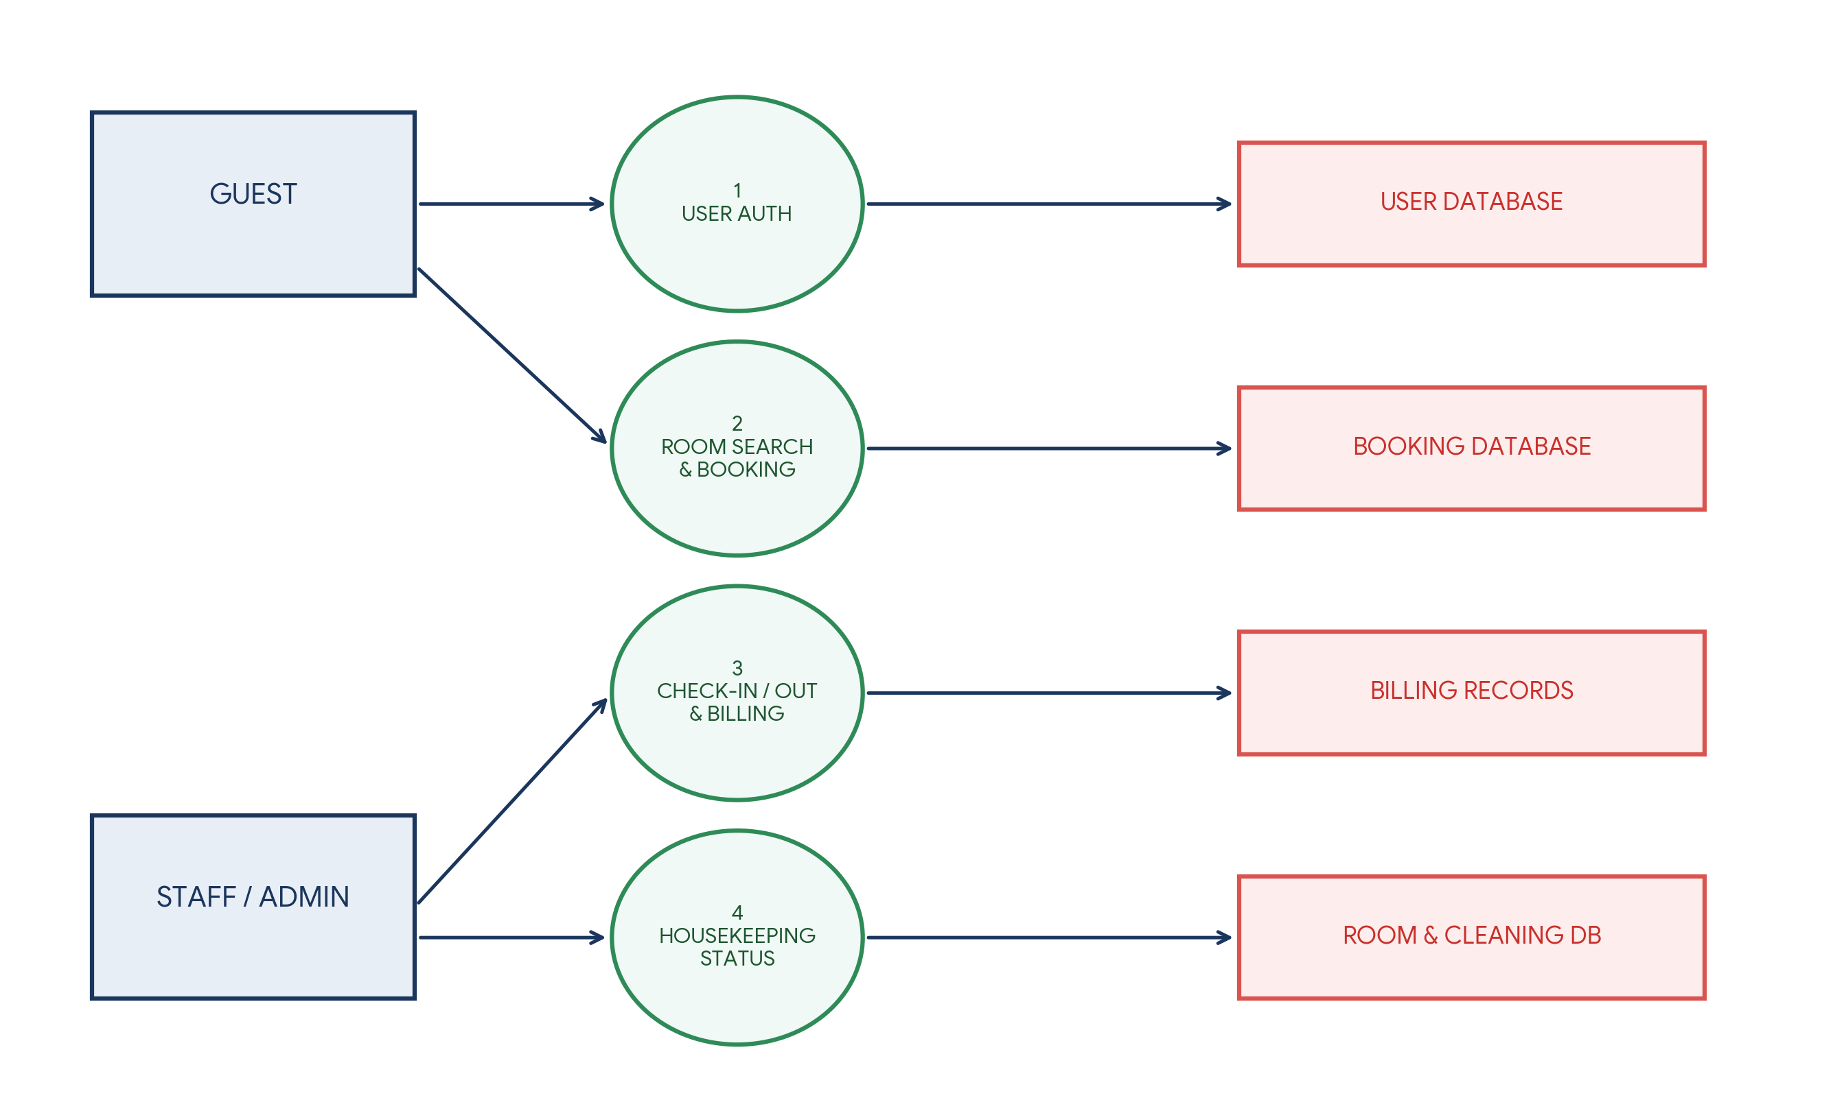

User Stories:
User Story Table – HotelPro Management System
User Type | Functional Requirement (Epic) | User Story / Task | Acceptance Criteria | Priority | Release
Guest | User Authentication | As a guest, I can create an account and log in securely. | JWT token generated and saved in browser storage. | High | Sprint-1
Guest | Room Discovery | As a guest, I can search rooms by check-in/out dates. | Returns live available rooms with total price calculation. | High | Sprint-1
Guest | Reservation Engine | As a guest, I can reserve a room and pay online. | Booking confirmation ID generated and sent via email. | High | Sprint-2
Receptionist | Check-In / Check-Out | As staff, I can check-in guests and assign physical keys. | Room status changes from 'Booked' to 'Occupied'. | High | Sprint-2
Housekeeper | Housekeeping Status | As housekeeper, I can update room status to 'Cleaned'. | Room becomes available for new guest bookings immediately. | Medium | Sprint-2
Receptionist | Billing & Invoicing | As staff, I can generate itemized bills upon check-out. | Calculates room charges, taxes, and outputs printable receipt. | High | Sprint-2
Manager | Reporting Analytics | As a manager, I can view total monthly occupancy & revenue. | Dashboard displays accurate visual charts & metrics. | Medium | Sprint-2

